1)Provide the proper IUPAC name for the chemical structure shown below or the chemical structure for the IUPAC name given.
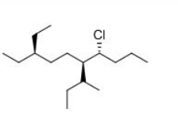

a._____________________________ b._____________________________

c.(2R,4R)-2-bromo-7-methyl-4-tert-butyloctane d.trans-1-sec-butyl-3-isopropylcyclohexane

2) Rank the following in order of decreasing acidity (1= most acidic, 4= least acidic)

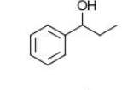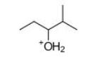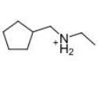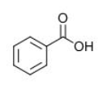
_______ _______ _______ _______

3) Rank the following compounds in order of decreasing melting point (1= highest, 4= lowest)
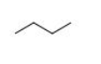
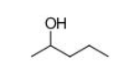
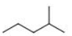
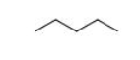

__________ __________ __________ __________

4) a. Draw a Newman projection for the compounds below. Assume you are spotting down as following:

b. Using molecule number 1 to draw an energy diagram for every conformation.

5) a. Circle the most stable isomer of 1,2,3-trimethylcyclohexane below:
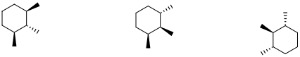
b. Draw both chair conformations of the isomer you selected, and circle the more stable chair.

6) Considering these two molecules:

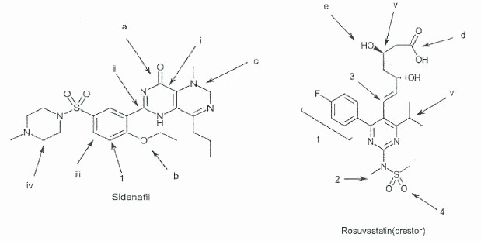

- Identify the indicated functional groups:

- .

b) Identify the hybridization of the indicated atoms:

What is the ideal bond angle for 1 and 2?
Angle for 1:
Angle for 2:

d) How many lone pairs are in both structures? Please draw all the lone pairs on both structures.

7) Identify the relationship between each pair of compounds - diastereomers, enantiomers, constitutional isomers, or the same compound:

- and

- and

- and

- and

8) Fill in the MO diagram of CN- (Valence e- only). Please clearly label the important elements (HOMO and LUMO).

Now think of reacting CN- with acetone. How will the electrons flow and explain why.
Hint:
Structure of acetone:
(in the C=O bond, C is partially positive and O is partially negative)

