OChem I Exam III

ASC Review

Fall 2018

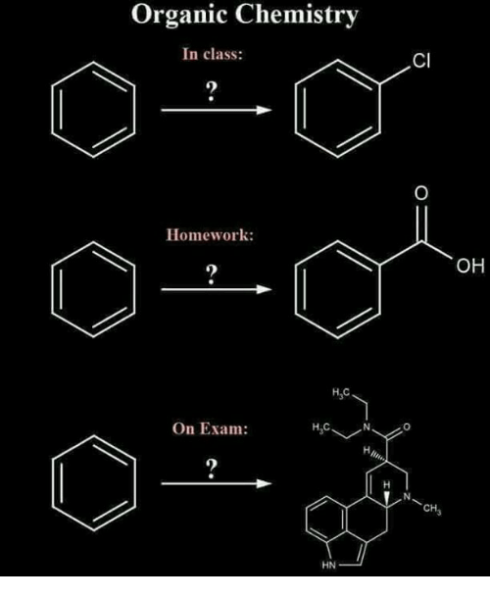

1. Identify the two structures with the correct IUPAC names. Don’t forget to include stereochemistry where appropriate.



___________________ ___________________

Using the two IUPAC names provided, draw the correct corresponding structures. Don’t forget to include stereochemistry where appropriate.

C. 1-chloro-3-methyl-4-isopropylcyclohexane D. (3S,4R)-4-Chloro-3,4-dimethylcyclopentene

2. Give the pKas of the hydrogens indicated by a,b,c. Label the functional groups for d,e,f.

b

e

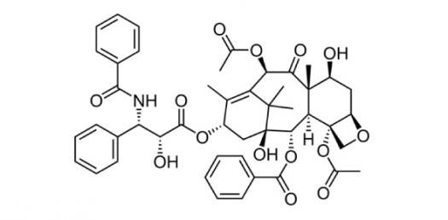

f

d

c

a

3. Predict the **major** products of or supply the appropriate reagents for the following reactions. Don’t forget to include stereochemistry where appropriate.



4. Provide the complete mechanism for the following transformations. You should include all electron flow arrows, intermediates and resonance structures.





5. Propose a synthesis for the following reaction. Have fun ☺



6. Determine the correct molecular structure of a compound with chemical formula C10H10O from the following spectra.

