Academic Skills Center
Gen. Chem. III Exam Review

- Balance the following chemical reactions
  - ___ZnCl₂ + ___AgNO₃ ___Zn(NO₃)₂ + ___AgCl

  - ___S₈ + ___HNO₃ ___H₂SO₄ + ___NO₂ + ___H₂O

- Given the following unbalanced equation: H₂ + N₂ NH₃
  - What is the balanced chemical reaction?

  - If there are 6 g of H₂ and 12 g of N₂, how many moles of each reactant are there?

  - Which is the limiting reactant?

  - How many grams of NH₃ are produced?

- Given 114 g of Al and 186 g Cl₂:
  - What is the greatest amount of AlCl₃ that can be produced?

  - If you produce 75 g of AlCl₃, what is the % yield of the reaction?

- How many grams of CO₂ are produced by burning 180 g of C₆H₁₂O_{6?}

- Given the following:
Hg(s) + Cu²⁺(Aq) Hg²⁺(Aq) + Cu(s)
Hg²⁺ +2e⁻⁻ Hg Eº = 0.85 V
Cu²⁺ +2e⁻ Cu Eº = 0.34 V
  - What is oxidized?

  - What is reduced?

  - What is the voltage generated by this cell?

  - What is the anode?

  - What is the cathode?

  - Draw this cell

- In which scenario(s) is entropy increasing?
  - H₂O(l) H₂O (g)
  - H₂O(l) H₂O (s)
  - 2H₂(g) + N₂(g) 2H₂N (g)
  - None of the above

- Given 15 g of H₂ at STP (standard temperature and pressure):
  - Calculate the number of moles of H₂

  - What is the volume taken up by this gas?

  - If the temperature is increased to 350K, and volume stays the same, what is the new pressure?

- If you have a 100mL of 10M HCl
  - How many moles of acid are present?

  - How many mL of 5M NaOH must be added to neutralize this solution?

  - Draw this titration curve

- The new element Elementy McElement Face has been recently discovered! After conducting a few tests, the following phase diagram was created:
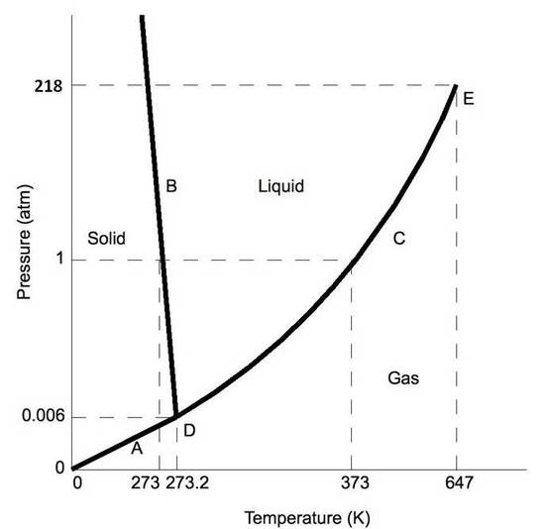

  - Label and define the triple point.

  - Label and define the critical point.

  - What state of matter is Elementy McElement Face in at 420 Torr and 70°C?

