General Chemistry Review: Exam 1
Presented by the Academic Skills Center Spring 2019

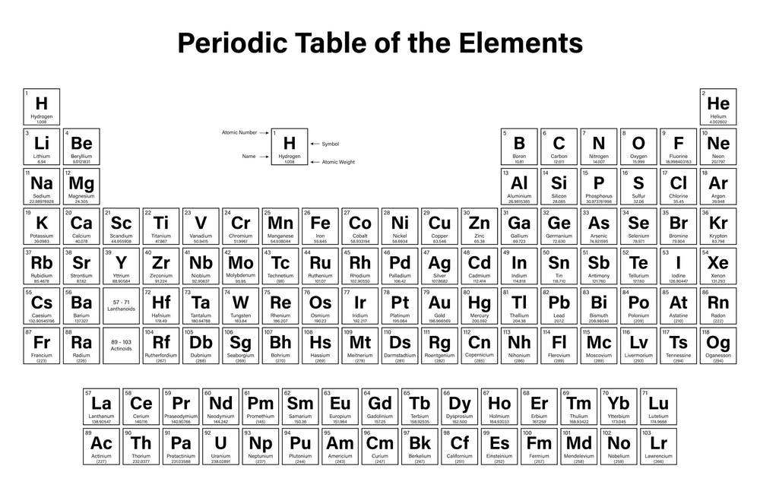

Topics:
Chapter 13: Colligative Properties
Chapter 14: Entropy

- What are the three intermolecular forces which hold molecules together in liquids and solids?

- What is the process by which each solute molecule is separated from one another and surrounded by the solvent?

- Label the types of intermolecular interaction occurring on the three images below:

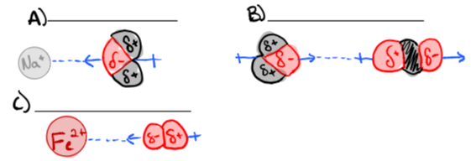

- What is the difference in molarity and molality?

- What is the difference in molality and percent by mass (also called percent by weight)?

- Household rubbing alcohol is a combination of isopropyl alcohol (C3H7OH) and water that is 70 Percent isopropyl alcohol by mass (density = 0.79 g/mL at 20°C). Express the concentration of Isopropyl alcohol in rubbing alcohol in (a) molarity and (b) molality.

- b)

- What factors affect solubility?

- Ethylene glycol [CH₂(OH)CH₂(OH)] is a common automobile antifreeze. It is water soluble and fairly nonvolatile (b.p. 197°C). Calculate (a) the freezing point and (b) the boiling point of a solution containing 685 g of ethylene glycol in 2075 g of water.

- The osmotic pressure if a 0.0100 M potassium iodide (KI) solution at 25°C is 0.465 atm. Determine the experimental van’t Hoff factor for KI at this concentration. (R=0.08206 L•atm/K•mol)

- A solution made by dissolving 14.2 g of sucrose in 100 g of water exhibits a freezing-point depression of 0.77°C. Calculate the molar mass of sucrose.

- Describe a colloid.

- What is the difference in a hydrophobic substance vs. a hydrophilic substance?

- Predict the spontaneity of the following reactions:
  - H₂O (l) → H₂O (g)

  - 6CO₂ (g) + 6 H₂O (l) → C₆O₁₂H₆ (s) + 6O₂ (g)

  - 2Ni₂O₃ (s) → 4Ni(s) +3 O₂ (g)

  - 2MgO(s) → 2Mg(s) + O₂ (g)

- A certain reaction is spontaneous at 25°C. If the enthalpy change for the reaction is 20 Kj/mol, what is the minimum value of ΔS for the reaction?

- Given the following information, predict whether the following reactions are spontaneous at 23.7°C.
  - ΔS = -124 J/k*mol, ΔH = 140 kJ/mol

  - ΔS= 146 J/k*mol, ΔH = 1 kJ/mol

  - ΔS = 50 J/k*mol, ΔH = -25 Kj/mol
- What is the temperature required to make each of the following spontaneous?
  - ΔS = -324 J/k*mol, ΔH = 40 kJ/mol

  - ΔS= 26 J/k*mol, ΔH = 12 kJ/mol

  - ΔS = 50 J/k*mol, ΔH = -25 Kj/mol

- The enthalpy change in the denaturation of a certain protein is 125 Kj/mol. If the entropy change is 397 J/K*mol, what is the minimum temperature at which the protein would denature spontaneously?

