ASC Ochem II review 1
Mr. Stark I don’t feel so good

- Label the following
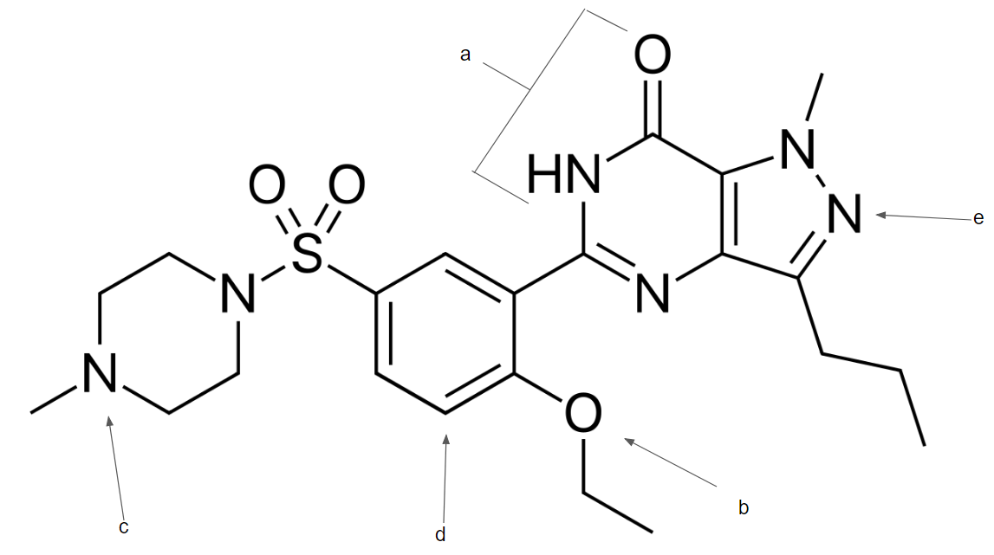
Functional groups:

Pka
c.

- Draw/name the following molecules
  - (1E,3Z,5Z) 1-bromo-3-ethyl-5-methyl-cyclohepta-1,3,5-triene

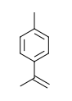

  - 3-chloro-4-ethylanisole

  - 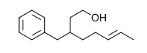

- Rank the following molecular orbitals in terms of their energy levels from lowest to highest.
- - + + + + -
- + + + + + +
- - + - - + -
- - + + - - +
- - + - + - +
- - - - + + +

- Which of the following is aromatic? Assume all molecules are planar.
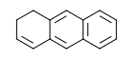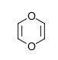

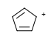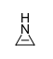

- Time for predict the products :D
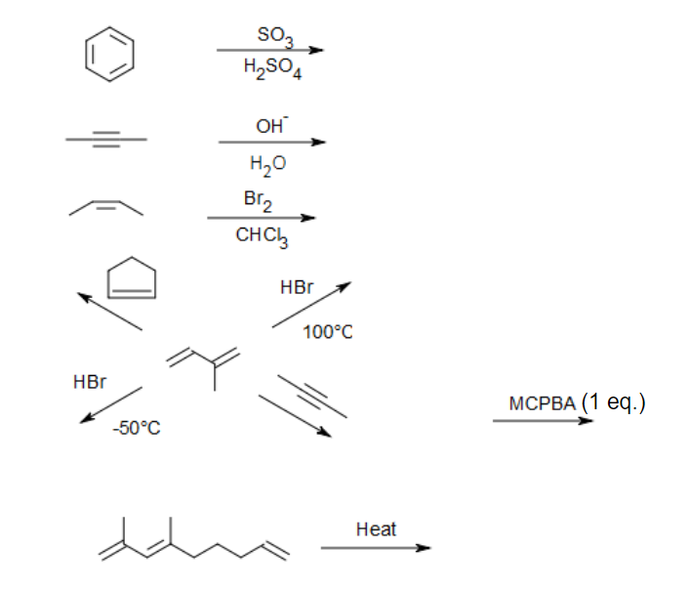

- Draw the mechanism for the following reaction. Include all resonance structures if present.

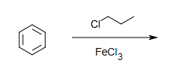

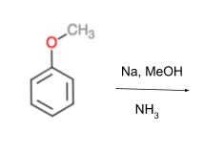

- Complete the following synthesis
