Exam 3
Chem 112- General Chemistry
Spring 2019

Instructions
- Read the instructions for each question carefully.
- You may use the Periodic Table below and a calculator to answer the following questions
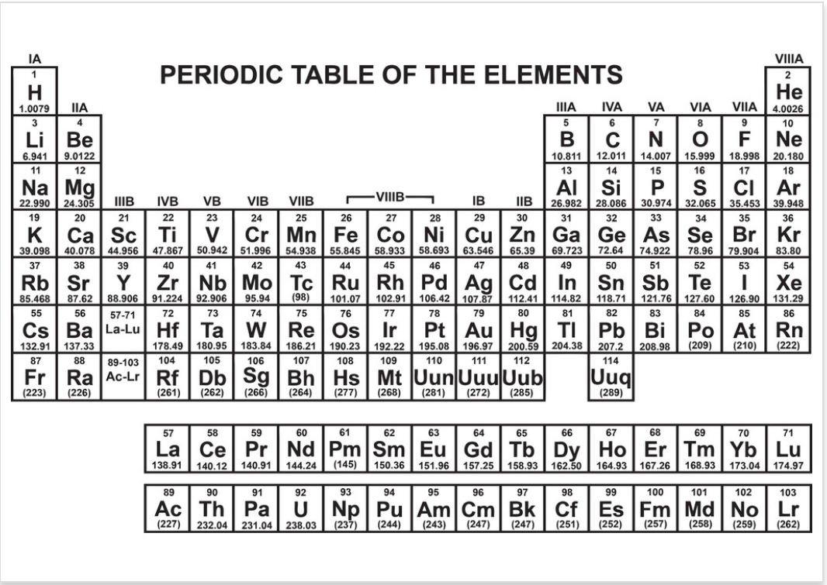

Good luck!
This material was distributed by the Austin College Academic Skills Center in the General Chemistry Tutorial Series

Contact for ASC for tutoring sessions and other information!
(903) 813-2454

- Define the endpoint and the equivalence point of a titration and how are they related to each other?

2. Draw the curves for the following titrations. Label the axes and equivalence point on the graph
- The addition of strong acid into strong base
- The addition of strong acid into weak base
- The addition of strong base into weak acid

3. Determine if the following solutions are buffers (or not). Explain.

- A solution containing benzoate and benzoin acid. The pH of benzoic acid is 6.60, and the pKa is 4.20.

(b) A solution containing acetate and acetic acid, with the concentration of acetic acid being double that of acetate.

4. What ratio of [Cl⁻] to [HCl⁻] should be used to make a buffer of pH 4.94, given the pKa of HCl is 4.76?

5. The pKa of acetic acid is 4.74. Calculate the pH in the titration of 50.0 mL of 0.100 M acetic acid by 0.200 M sodium hydroxide after the addition of:
- 10.0 mL of NaOH

- 25.0 mL of NaOH

- 40.0 mL of NaOH

6. Explain the difference (in words and equations) between Ka, Kb, Ksp, solubility, and molar solubility.

7. Calculate molar solubility( in grams per liter) of AgBr in a 0.030M solution of AgNO₃ given K_{sp} of AgBr at 25°C is 5.0 x 10⁻¹³

8. Answer all parts of the question below.

(a). What are the oxidation states and overall contribution of charge for the elements in the reaction below?

SO²⁻₃ (aq) + MnO₄⁻ (aq) → SO²⁻₄ (aq) + Mn²⁺ (aq)

(b). Identify and re-write the oxidation and reduction half-reactions

Oxidation:

Reduction:

( c ). Combine the half-reactions to obtain the overall redox reaction.

9. In a galvanic cell, oxidation occurs at the ____ode and reduction occurs at the ____ode. Cations move towards the ____ode which is ___ charged, whereas anions move towards the ___ode, which is ___ charged.

10. Answer all parts of the question below.

(a). Calculate the most positive standard reduction potential for the Zr and I₂ electrodes:

2e⁻ + I₂ _{(s)} → 2 I⁻ _{(aq)} E°= 0.54 V

4e⁻ + Zr₄⁺ _{(aq)} → Zr _{(s)} E°= -1.53 V

(b). Calculate the cell potential (E) at 25°C using your answer above, the Nernst equation, and the concentrations of [I⁻]= 0.75M and [Zr⁴⁺]= 1.3M.

Nernst Equation: E= E°- RT/ nF (lnQ) E= E°- 0.0592/ n (logQ)

( c ). Is this reaction going to occur spontaneously? Why or why not?

