Exam 2
Chem 222- Organic Chemistry
Spring 2019

Instructions
- Read the instructions for each question carefully.
- You may use the Periodic Table below and a calculator to answer the following questions
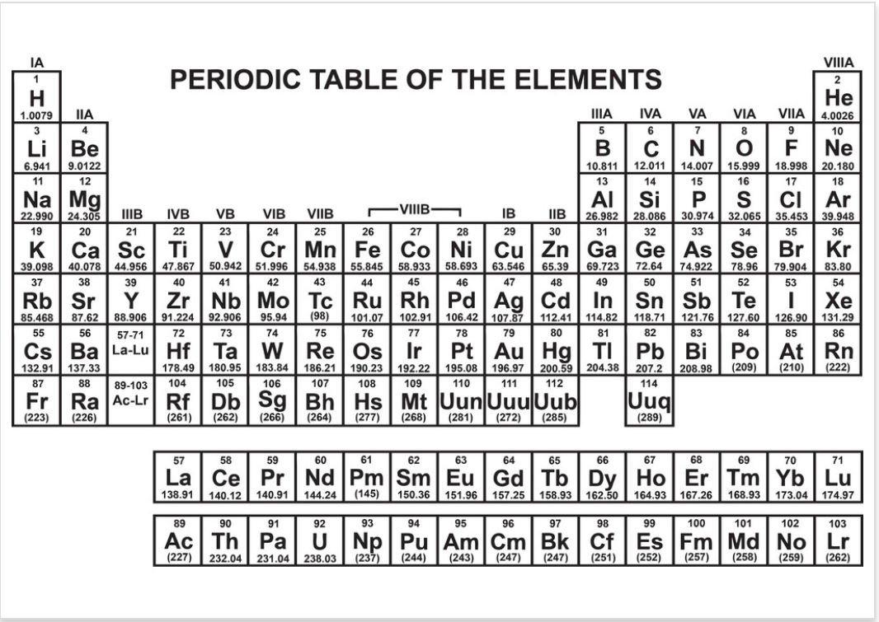

Good luck!
This material was distributed by the Austin College Academic Skills Center in the General Chemistry Tutorial Series

Contact for ASC for tutoring sessions and other information!
(903) 813-2454

- Provide either the proper IUPAC name or the correct structure for the following compounds
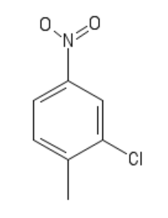
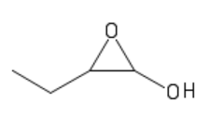
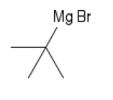

__________________ __________________ ____________

- Provide the indicated reaction information- product, reactant/reagent, or starting material. For the products predict the major products. If no reaction occurs write “No rxn.” Indicate stereochemistry where appropriate. (eq. = equivalent; r.t. = room temperature)

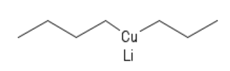
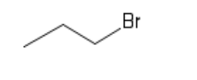
a.) + →

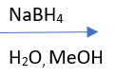
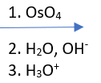
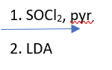
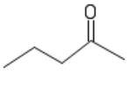
b.)

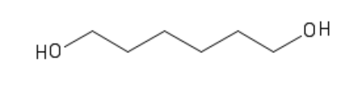
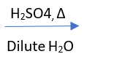
c.)

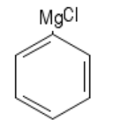
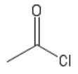
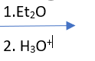
d.)
- 2. eq

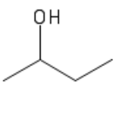
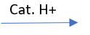
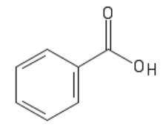
e.) +

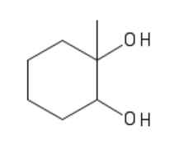

f.)

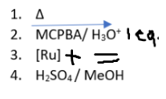
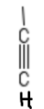

g.)

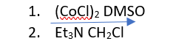
h.) product form g.)

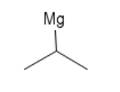

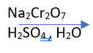
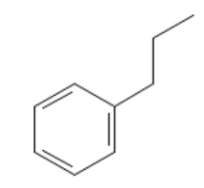
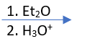
i.)

- The reactivity of acid anhydrides towards nucleophiles is much greater than the reactivity of esters. Use resonance structures and proper organic chemistry terminology to explain why acid anhydrides demonstrate lower reactivity towards nucleophiles than ketones.
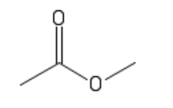

`
acid anhydride ester

4. Provide a reasonable synthetic pathway to synthesize the product shown utilizing the guidelines provided in each question. Remember to include the complete reagents and solvents (when appropriate) for each step in you synthesis.
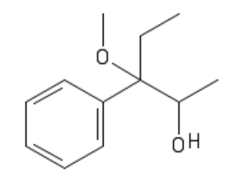
‘

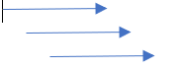
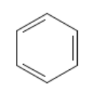
Additional reagents: less than or equal to 3 carbons

5. Draw the complete arrow pushing mechanisms for the following transformations. Remember to include all charges, intermediates, and relevant resonance structures.
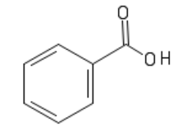
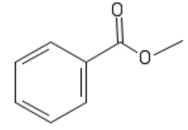
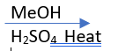

6. Rank the following compounds in order of fastest (1) to slowest (3) reaction with a Grignard Reagent.
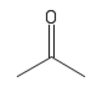
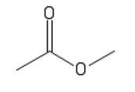
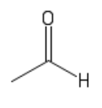

_____________ ______________ ______________

7. Provide the letter(s) of the compounds(s) that accurately fits into the sentence below. Include all applicable compounds in ou anser. If no compounds fit write “none.”
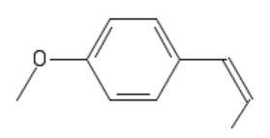

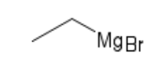

NaBH₄ LAH

A B C D

_____ a.) will reduce carboxylic acids
_____ b.) can be used directly in cross-coupling reaction
_____ c.) will open an epoxide and attack at the more substituted position
_____ d.) will react with aldehyde carbonyl carbons

8. The ¹H and ¹³C NMR spectra of product “X” is shown below. Use your knowledge of NMR, to identify product “X” if it has a molecular formula of C₈H₈O₃

¹H NMR spectra
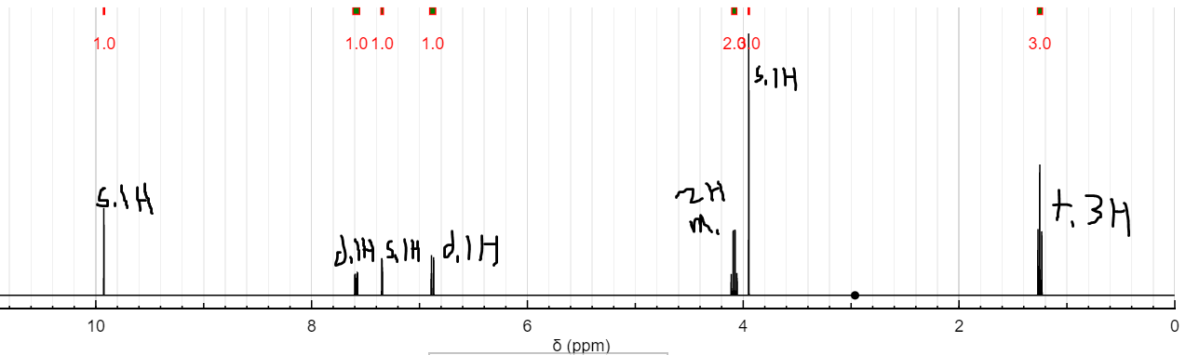

¹³C NMR
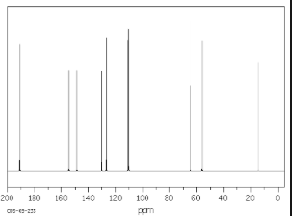

Product X:

Additional Space for scratch work:

