Exam 1

CHEM 111 – General Chemistry I

Fall 2019

Instructions:
- Read the instructions for each question carefully
- Take 5 minutes to work each individual problem on your own, after 5 minutes we will discuss the solution as a group
- You may use the Periodic Table below and a calculator to answer the following questions.

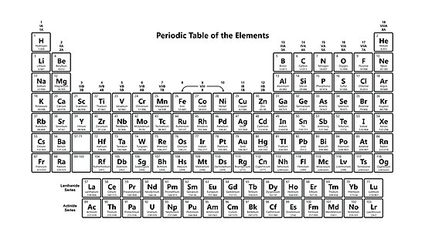
This material was distributed by the Austin College Academic Skills Center in the General Chemistry Tutorial Series.

Contact the ASC for tutoring sessions and other information

(903) 813-2454

- In your own words, describe Rutherford’s famous experiment regarding atomic structure and his findings.

- Convert 34.5 ft to mm.

- Convert 310.0 degrees Kelvin into Fahrenheit.

- Identify if the following examples are homogeneous mixtures, heterogeneous mixtures, or pure substances:
- Arsenic
- Lava lamp
- Bowl of chili
- Blood
- The air we breathe

- Identify each of the following as a chemical or physical property:
- Ionization energy
- The smell of sulfur
- The ability of a metal to conduct heat
- Bleaching your hair
- The color of grass

- Do the following calculations to the correct significant figures:
- 15.05 x .50
- 113.3 / 13.1
- 650.2 - 45.2 x 13.5

- How many electrons are associated with these quantum numbers?
n | l | m_{l} | m_{s} | number of e⁻
3 | 2 | 0 | +1/2
4 | 1

- What are the electron configurations of the following elements:
- Potassium:
- Silver:
- Krypton:
- Technetium:

- On the four targets below, illustrate these four situations:
Low accuracy Low accuracy High accuracy High accuracy
High precision Low precision High precision Low precision

- If I have three and a half dozen eggs, how many moles of eggs do I have?

- You have a 4.82 gram cube of platinum in 50.0 mL of canola oil (the density of platinum is 21.447 kg/m³).

- Find the volume in cm³ of the cube:

- The density of canola oil is 0.90 g/cm³ - does the cube sink or float in the oil?

- How many moles of platinum are in the cube?

- Identify the following:
- Atomic number of chromium:
- Mass number of selenium:
- Number of electrons around calcium:
- Number of neutrons in rubidium:
- Charge of a proton, neutron, and electron:

- In your own words, describe what an isotope is:

- Draw the shape of the following orbitals: s, p, d:

- Using your understanding of atomic and ionic radii, explain how each radius would be different in Se and Se²⁻. Make sure to specify which is the atomic and which is the ionic radius and how you can tell.

- Microwave ovens emit microwave energy with a wavelength of 12.9 cm. What is the energy of exactly one photon of this microwave radiation?

- Find the average atomic mass of magnesium given 3 isotopes, their masses, and percent abundance.
²⁴Mg has a mass of 23.985 with a percent abundance of 78.70%
²⁵Mg has a mass of 24.985 with a percent abundance of 10.13%
²⁶Mg has a mass of 25.983 with a percent abundance of 11.17%

