Exam 2
CHEM 111- General Chemistry I
Fall 2019

Instructions: Read the instructions for each question carefully and answer the questions to the best of your ability. You may use the Periodic Table below and a calculator to answer the following questions.

Periodic Table of the Elements
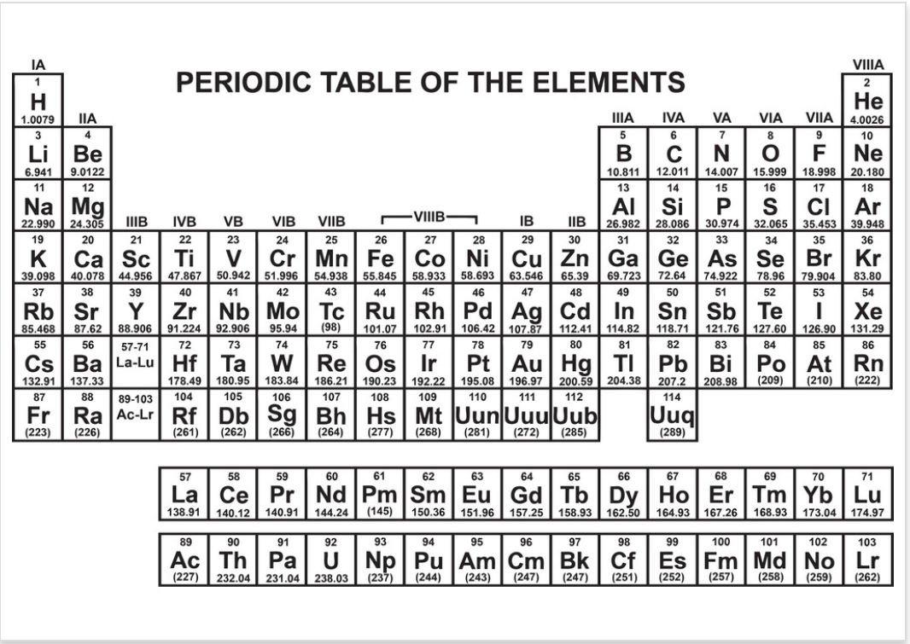

Good luck!
This material was distributed by the Austin College Academic Skills Center in the General Chemistry Tutorial Series.

Contact the ASC for tutoring sessions and the other information!
(903) 81302454

- Periodic Trends:
  - Identify the relationship between elements in the same group.

  - Identify the relationship between elements in the same period.

- Classify the elements as metal, nonmetal, or metalloid:
  - Ba -
  - S -
  - Tc -
  - H -
  - Te -

- Describe effective nuclear charge and using chemical vocabulary, explain why atomic radius trend with respect to increasing period and increasing group number.

- Cations are ______ than anions of the same element (in relation to size).

- Write the name of the following molecules:
  - BF₃
  - Rb₂O
  - NH₃
  - Cu₃(PO₄)₂
  - K₂SO₃
- Write chemical formula for each of the following:
  - Iron(III) Sulfide-
  - Magnesium Permanganate -
  - Sodium Sulfite
  - Sodium Dichromate
- Draw the following and identify all the intermolecular forces associated with them:
  - Nitrite

  - H₂O

  - CF₄

  - KCN
- Write the electron configuration for the following ions (Noble gas notation and full)

I

Ag

Ni²⁺

- Identify the element from this electron configuration: [Ar] 3d⁹
- Rank from highest to lowest:
  - Atomic Radius of : Cl, Ni, Fr, Al, Kr

  - First Ionization Energy of: Cd, O, B, Rb, Cs

  - Electronegativity of: Se, F, Ca, O, C

  - Second ionization energy of: K, Rb, Sr, Ca, Na

- Draw the Lewis Structure for PCl₅. State the molecular geometry, formal charge of each atom, and the hybridization state. Show the dipoles with a vector arrow and indicate the net dipole moment.

- Draw all of the resonance structures and the resonance hybrid for nitrate. State the molecular geometry, formula charge of each atom, and the hybridization state. Show the dipoles with a vector arrow and indicate the net dipole moment.

- Identify the percent composition of each of the elements present in C₆H₁₂O₆.

What is the empirical formula of a compound containing 40.92% C, 4.58% H, and 54.50% O?

- If the compound from the above question has a known molecular weight of 176.12 g/mol, what is the molecular formula?

- Fill in the electrons in following MO diagram for O₂ ²⁺ and O_{2.}
(Your professor might not have taught you this, if they didn’t don’t worry about this question.)

