Exam 4
CHEM 111- General Chemistry I
Fall 2019

Instructions
- Read the instructions for each question carefully
- You may use a periodic table and a calculator to answer the following questions
- Attempt each question in a 3-5-minute period, after which we will review each problem before moving onto the next one.
- Work ahead if you have time between solving and discussing each problem.
- The answer key is available in the ASC if you would like to come in and check your work

Good Luck!

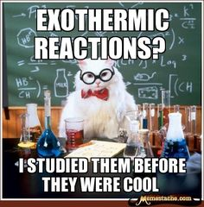

This material was distributed by the Austin College Academic Skills Center in the General Chemistry Tutorial Series

Contact the ASC for tutoring sessions and other information!
(903) 813-2454
- A sample of carbon dioxide, CO2, occupies 0.300 L at 10 °C and 750 torr. What volume will the gas have at 30 °C and 750 torr?

- An unknown gas effuses 1.66 times more rapidly than CO₂. What is the molar mass of the unknown gas?

- The following is a phase diagram for an unknown chemical.
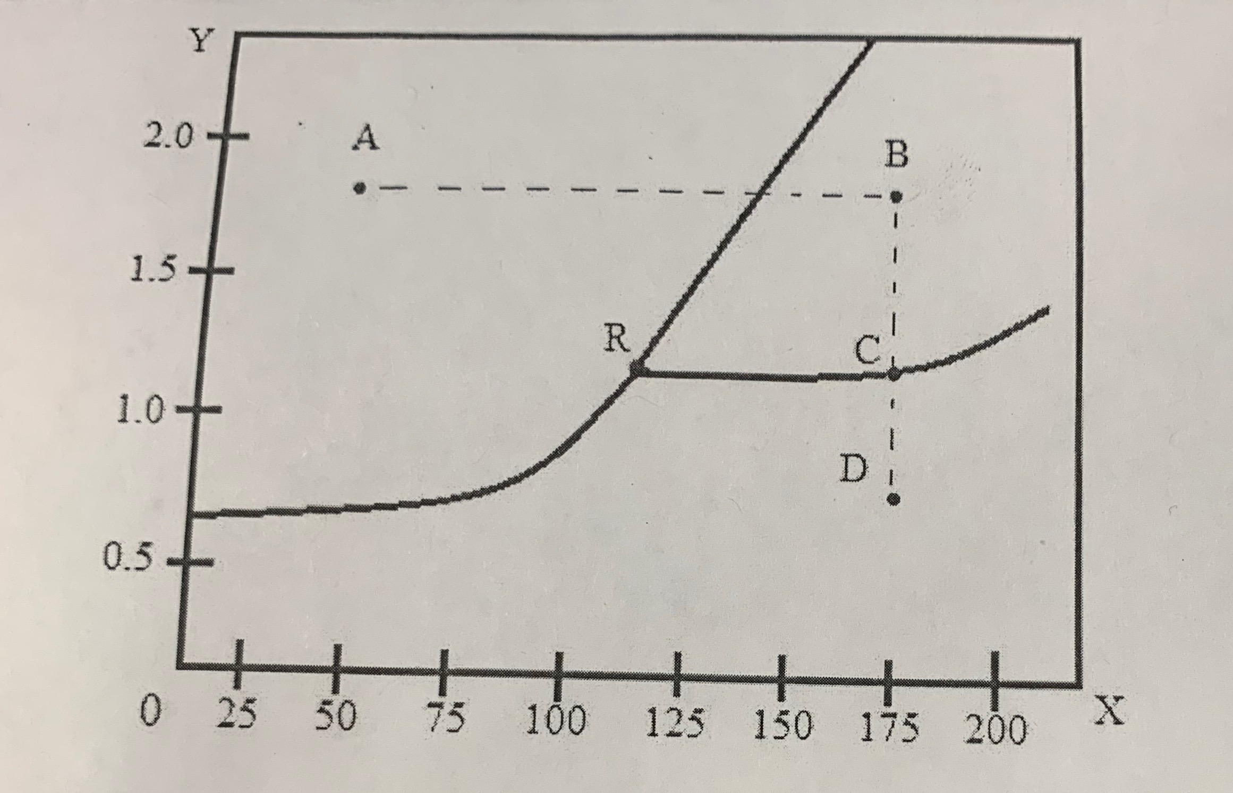

- Label the X and Y axes, including units

- What phase is the chemical in at points A, B, and C respectively?

- Discuss the significance of point R

- Is it possible to boil this compound at atmospheric pressure?

- What is the approximate melting point of this compound at twice the standard atmospheric pressure?

- Using Hess’s Law and given the following thermochemical equations, determine the enthalpy change for the given equation

NO (g) + O (g) NO₂ (g)

NO (g) + O₃ (g) NO₂ (g) + O₂ (g)
∆H= -198.9 kJ/mol

O₃ (g) $\frac{3}{2}$O₂ (g)
∆H= -142.3 kJ/mol

O₂ (g) 2O (g)
∆H= +495 kJ/ mol

- When 50.0 mL of 1.00 M HCl(aq) and 50.0 mL of 1.00 M NaOH(aq), both at 22.0 °C, are added to a coffee cup calorimeter, the temperature of the mixture reaches a maximum of 28.9 °C. What is the approximate amount of heat produced by this reaction? Is this reaction endothermic or exothermic? What do these phrases communicate to us?

HCl(𝑎𝑞)+NaOH(𝑎𝑞)⟶NaCl(𝑎𝑞)+H2O(𝑙)

- List 2 postulates of Kinetic Molecular Theory

- Why is kinetic molecular theory important? What does it help us understand?

- A 10.0-L vessel contains 2.50 × 10⁻³ mol of H₂, 1.00 × 10⁻³ mol of He, and 3.00 × 10⁻⁴ mol of Ne at 35 °C.
- What are the partial pressures of each of the gases?

- What is the total pressure in atmospheres (atm)?

- Cyclopropane, a gas once used with oxygen as a general anesthetic, is composed of 85.7% carbon and 14.3% hydrogen by mass. Find the empirical formula. If 1.56 g of cyclopropane occupies a volume of 1.00 L at 0.984 atm and 50 °C, what is the molecular formula for cyclopropane?

- Methane, CH₄, is being considered for use as an alternative automotive fuel to replace gasoline. One gallon of gasoline could be replaced by 655 g of CH₄. What is the volume of this much methane at 25 °C and 745 torr?

- A metal pellet with a mass of 100.0g, originally at 88.4°C, is dropped into 125g of water originally at 25.1°C. The final temperature of both the pellet and the water is 31.3°C. Calculate the heat capacity C (in J/°C) of the pellet. The specific heat of water is 4.184 J/g°C.

